K.R. Mangalam University

School of Engineering & Technology

Assignment
Probabilistic Modeling and Reasoning

Submitted by: Submitted to:
Name: ANURAG KUMAR MISHRA Dr. Kunal Rai
Roll No: 240120107
Course: BCA (AI & DS) Sec: B

ASSIGNMENT 1
Q1. Bike Prices:
(a) Calculate the Mean Price
- Sum all prices: 12000 + 15000 + 18000 + 20000 + 50000 = 119000
- Total bikes counted: 5
- Mean price = Total sum ÷ Number of bikes = 119000 ÷ 5 = ₹23,800
(b) Find the Median Price
- Order the prices: 12000, 15000, 18000, 20000, 50000
- With an odd number of entries, the median is the middle (3rd) value = ₹18,000
(c) Which Average to Highlight?
- The mean is strongly influenced by the high priced ₹50,000 bike.
- The median remains stable and better reflects typical prices.
- Therefore, promoting the median price (₹18,000) will make the bikes appear more budget-friendly.

Q2. Relationship Between Histogram Shape and Central Tendency in Left-Skewed Distribution:
- Left-skewed data has a longer tail on the left side.
- The mode is greater than the median, which is greater than the mean (Mode > Median > Mean).
- The mean is drawn in the direction of the skew (left) making it less than the median.

Q3. Exam Scores Analysis:
(a) Mean Calculation:
- Sum of scores: 67 + 72 + 78 + 85 + 90 + 91 + 95 = 578
- Total scores: 7
- Mean = 578 ÷ 7 ≈ 82.57
(b) Median Determination:
- With 7 values, the median is the 4th number when sorted = 85
(c) Mode Identification:
- Since each score appears once, there is no mode.
(d) Distribution Shape:
- The distribution appears fairly symmetrical because the mean and median are close.
(e) Five-Number Summary:
- Minimum = 67
- First Quartile (Q1) = Median of lower half = 72
- Median = 85
- Third Quartile (Q3) = Median of upper half = 91
- Maximum = 95

Q4. Difference Between Population Parameter and Sample Statistic:
- Population parameter: A measure summarizing an entire population (e.g., average income of all residents).
- Sample statistic: A measure derived from a subset (sample) of the population (e.g., average income from surveyed individuals).

Q5. Employee Salary Data:
(a) Calculate the Mean Salary:
- Salaries: 45000 + 50000 + 55000 + 60000 + 250000 = 460000
- Number of employees: 5
- Mean salary = 460000 ÷ 5 = $92,000
(b) Median Salary:
- Middle salary in ordered list is $55,000
(c) Choosing Which Average to Advertise:
- Company may prefer advertising mean salary ($92,000) due to its higher value.
- Employees might look more favorably on the median ($55,000) since it reflects the typical wage.
- The disparity is caused by an exceptionally high salary skewing the mean upwards.

Q6. Students Scores Analysis:
Same as Q3

Q7. Modes of transportation:
Sol:
(a) Frequency table:
Mode | Frequency
F (In-person) | 11
H (Hybrid) | 5
O (Online) | 4

(b) Bar chart would plot mode categories vs frequencies.

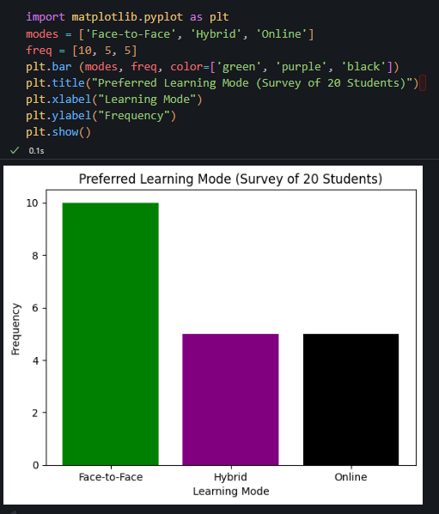

(c) Most popular mode: F (In-Person), 55% (11/20 students)
(d) Histogram not suitable for categorical data; bar chart is appropriate.

ASSIGNMENT 2
Q1. Probability of Second Marble Being Red Given First is Blue:
- Total marbles: 5 red + 7 blue = 12
- First marble drawn is blue, so remaining marbles = 11
- Remaining red marbles = 5
- Probability(second marble red | first blue) = Number of remaining red marbles ÷ Total remaining = 5/11

Q2. Probability of Having Disease Given Positive Test Result (Bayes' Theorem):
- Given:
  - P(Disease) = 0.01
  - P(No disease) = 0.99
  - P(Positive | Disease) = 0.95
  - P(Positive | No disease) = 0.02
- Using Bayes' Theorem:
  - Numerator = P(Positive | Disease) × P(Disease) = 0.95 × 0.01 = 0.0095
  - Denominator = (0.95 × 0.01) + (0.02 × 0.99) = 0.0095 + 0.0198 = 0.0293
  - P(Disease | Positive) = 0.0095 / 0.0293 ≈ 0.324
There is approximately a 32.4% chance the person has the disease after a positive test.

Q3. Revising Doctor's Opinion After Positive Test:
- Prior probability (doctor's estimate): P(Disease) = 0.30
- Compute posterior probability:
  - Numerator = 0.95 × 0.30 = 0.285
  - Denominator = 0.285 + (0.02 × 0.70) = 0.285 + 0.014 = 0.299
  - P(Disease | Positive) = 0.285 / 0.299 ≈ 0.952
The positive test increases the disease probability from 30% to about 95.2%.

Q4 & Q5. Probability Involving Students Studying Physics and Chemistry:
- Total students = 50
- Physics students = 30
- Chemistry students = 25
- Students studying both = 15
Calculate students studying only Physics:
- Only Physics = Total Physics - Both = 30 - 15 = 15
Calculate the probability a randomly chosen student studies only Physics:
- P(Only Physics) = 15 / 50 = 0.3
There is a 30% chance a chosen student studies Physics but not Chemistry.

ASSIGNMENT 3:
1. Project Objective:
Perform a complete Exploratory Data Analysis (EDA) on a dataset of your choice. Your goal is to understand the underlying structure of the data, discover patterns and relationships, identify anomalies and outliers, and test your initial hypotheses.
2. Dataset Selection:
You must select a dataset from (link unavailable) Choose a dataset that is rich enough to allow for meaningful analysis. It should have:
- At least 5 variables (columns).
- A mix of numerical and categorical variables is highly recommended.
- A sufficient number of rows (e.g., >100) to make analysis interesting.
Popular beginner-friendly datasets on Kaggle include: Titanic, Iris, House Prices, Netflix Movies and TV Shows, Wine Reviews, or Pokemon Datasets. You are free to choose any that interests you.
3. Technical Requirements:
Your analysis must include the following, implemented in Python:
- Data Loading & Inspection:
- Load the dataset using pandas.
- Display the first and last few rows (.head(), .tail()).
- Check the data types and summary info (.info(), .describe()).
- Data Cleaning (Mandatory):
- Identify and handle missing values. Explain your method (e.g., removal, imputation).
- Check for and handle any duplicate entries.
- Identify outliers using visualizations (e.g., boxplots) and describe how you treated them.
- Univariate Analysis (From Project 1):
- For numerical variables: Calculate and interpret Mean, Median, Trimmed Mean, Range, Variance, and Standard Deviation.
- For categorical variables: Calculate frequency counts and modes.
- Visualize distributions using histograms, KDE plots, and boxplots.
- Bivariate/Multivariate Analysis (From Project 2):
- Create scatter plots to explore relationships between two numerical variables.
- Create a correlation matrix and visualize it using a heatmap.
- Use grouped boxplots or bar charts to explore relationships between categorical and numerical variables.
- Conclusion:
- Summarize the 3-5 most important insights you discovered from your analysis.

Code:

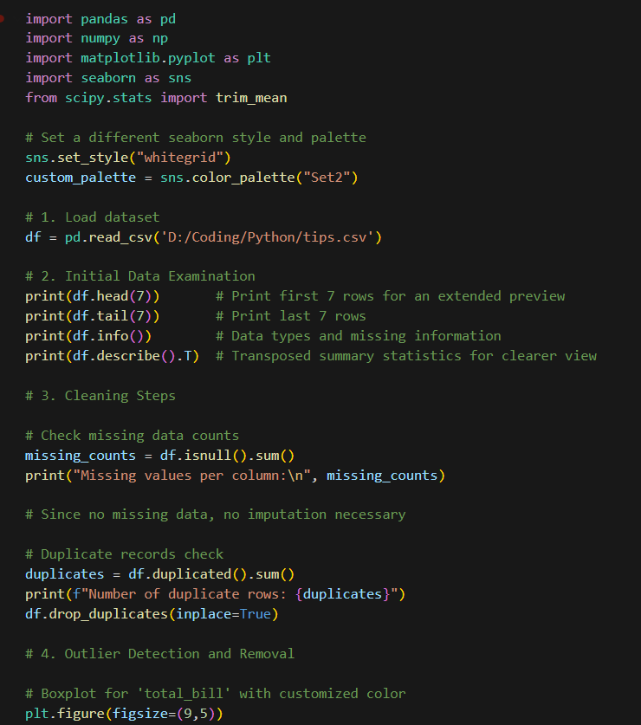

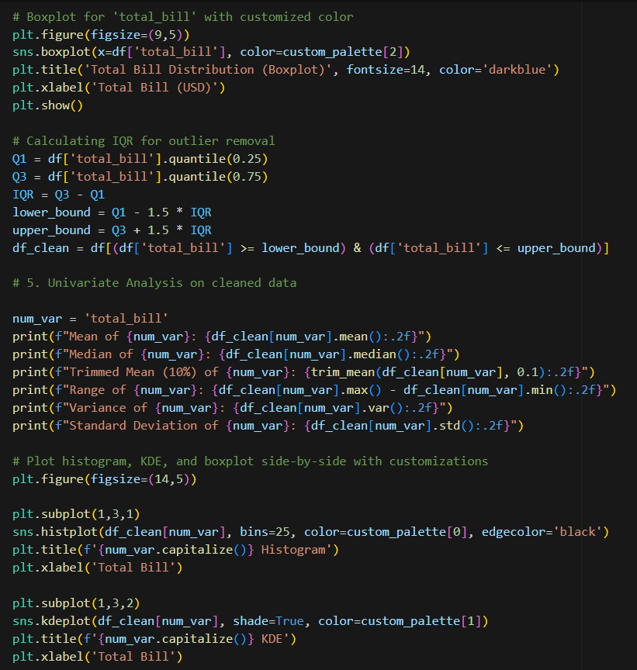

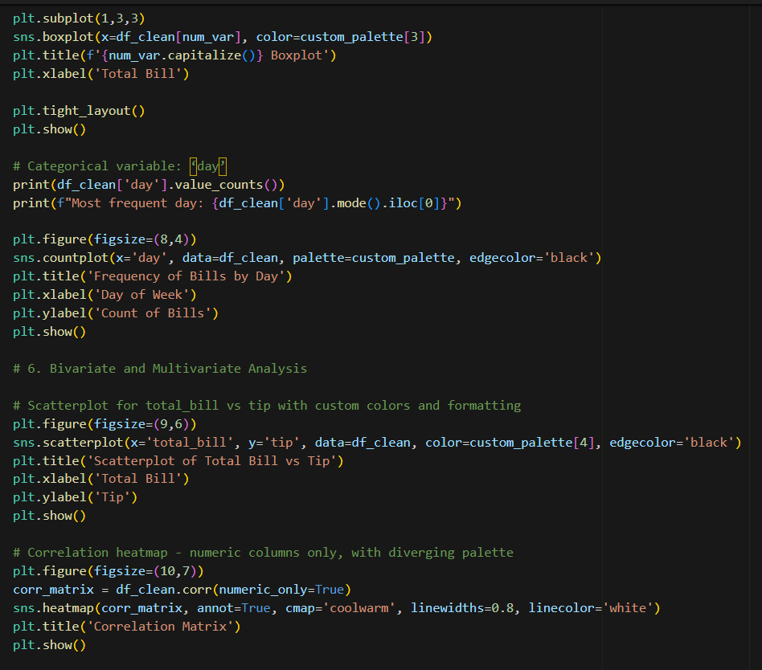

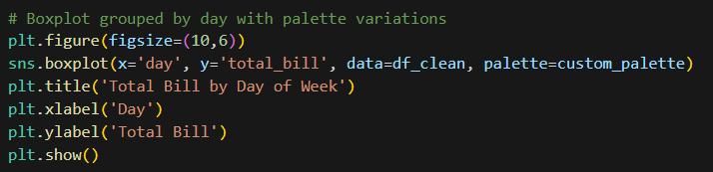

Output:
